**RAJIV GANDHI INSTITUTE OF TECHNOLOGY**

**ENGINEERING GRAPHICS**

**(S1 – CSE)**

**Assignment No 3 (To be submitted on 16/12/2024 )**

1. A pentagonal pyramid of base 30mm and altitude 55 mm rests on its base on the HP with one of its base edges perpendicular to VP. It is cut by a plane inclined at 60o to the base. The cutting plane meets the axis at 15mm above the base. Draw the front view, sectional top view and true shape of the section. What is the true height of the section?

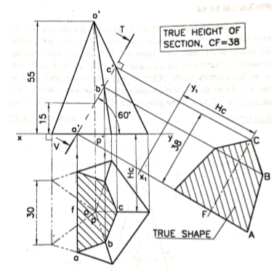

1. A hexagonal pyramid of base side 25 mm and axis 60mm rests on its base on the HP with two base edges perpendicular to the VP. It is cut by a plane perpendicular to the VP and inclined at 30o to the HP meeting the axis at 25 mm from the vertex. Draw the elevation, sectional plan and the true shape of the section. What is the maximum true length of the side in the section of the pyramid?

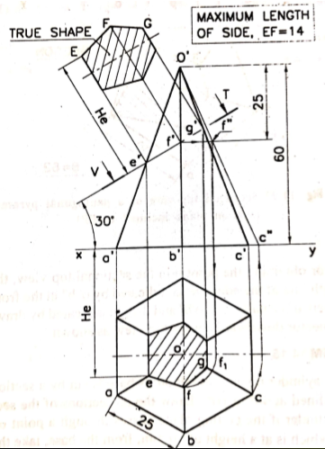

1. A cone of base diameter 120mm and height of 135mm is resting on HP on the base. It is cut by a section plane inclined at 45o to the HP and passing through a point on the axis and is 60mm below the vertex of the cone. Draw the front view, sectional top view and the true shape of section. Name the section obtained and mark its dimensions on it.

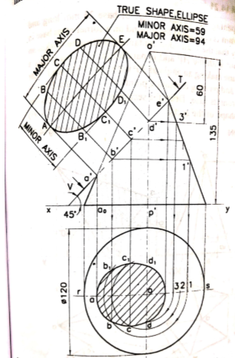

1. A pentagonal pyramid 30mm edge of base and 60mm height stands with its base on the ground and an edge of base perpendicular to VP. A section plane perpendicular to HP and inclined 30o to VP cuts the pyramid at a shortest distance of 5mm from its axis and in front of it. Draw its sectional views and true shape of the section.

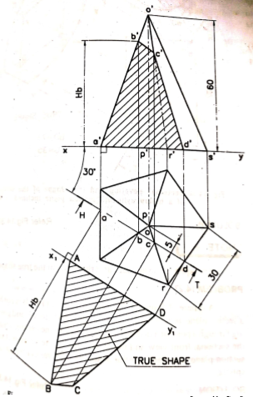

1. A right circular cone of 100mm base circle diameter and 50mm height is resting on its base on the ground. It is cut by a vertical plane inclined at 40o to the VP, the plane being at minimum distance of 15mm, from the axis of the cone. Draw the sectional elevation and true shape of the section. Assume that the section is in front of the axis.

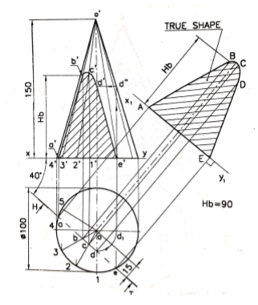

1. A square pyramid edge of base 30mm and height 50mm is resting on its base on HP with one of is base edges perpendicular to VP. A section plane perpendicular to VP and inclined to HP cut the pyramid in such a way the section and true shape of the section is trapezium. The length of parallel sides of the trapezium are 15mm and 25mm in the top view. Draw the front view showing the sectional plane, top view showing the section and true shape of the section. What is the inclination of the section plane. What is the height of the trapezium?

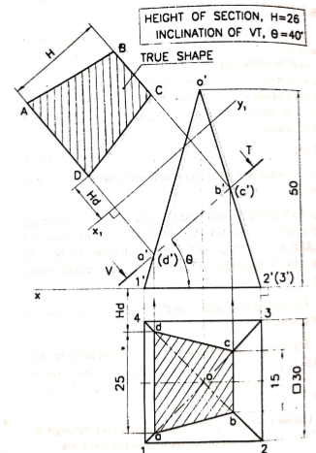

1. A cone of base diameter 60mm standing upright is cut by a section plane such that the true shape is a parabola of maximum double ordinate 50mm and vertex of the parabola is mm from ordinate. Draw front and top views and true shape of the section. Draw front and to views and true shape of the section. What is the inclination of the section?

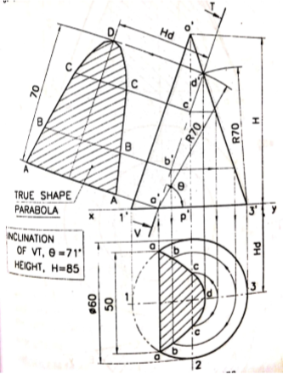

1. A square pyramid 30mm side of base and 55mm high stands vertically with one of its sides of base parallel to the VP. A section plane cuts the axis of the pyramid at 30mm above the base and is horizontal towards the left of the axis and at 45o to the right of the axis.

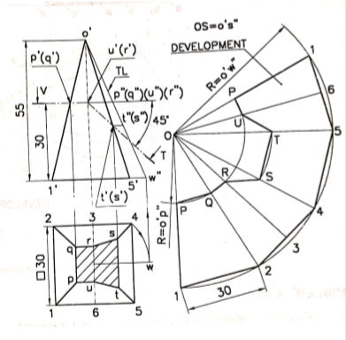

1. A sugar jar is in the form of a right circular cone of base diameter 60mm and height 90mm and it rests on HP. An ant starts moving from extreme left end of its base, returns to its starting point, after moving around it. Find geometrically the length of the shortest path the ant can take. Show this path In both front and top views.

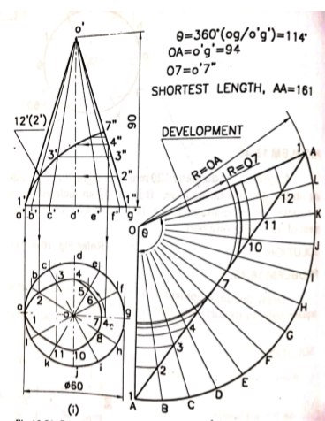

1. A right cone of diameter 60mm and height 90mm rests on the HP.. What is the shortest distance between the points P and Q on the surface of the cone? The point P is on the base of the cone and is nearer to the observer while the point Q is at a height of 60mm and is farther away from the observer. Assume that the points lie in a plane perpendicular to VP. Draw the front and top views of the cone showing the shortest distance. Note that the distance is to be measured along the surface.

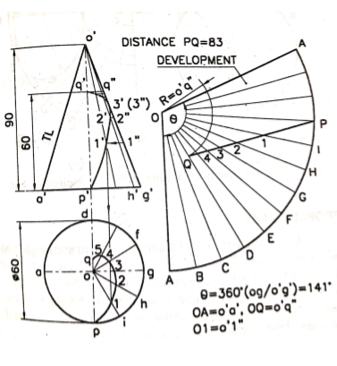

1. Draw the development of the cut portion of the cone shown in figure below.

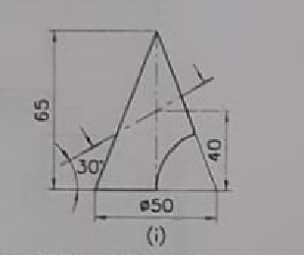

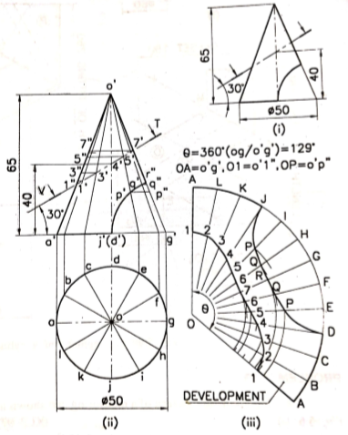

1. Draw the development of the lateral surface of a right regular hexagonal prism of 25 mm base edge and 70mm height. An ant moves on its surface from a corner on the base to the diametrically opposite corner of the top face by the shortest route. Sketch the path of the ant in the elevation

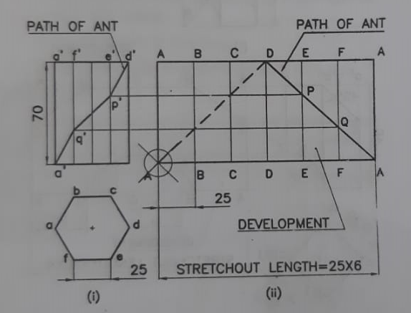

1. A cone of base diameter 48 mm and height 58mm is resting with its base on HP. The top portion is removed by a horizontal plane passing through a point which is 24mm below the apex of the cone. The bottom portion is then removed by a plane inclined at 30o to HP and passing through the extreme right of the base. Draw the development of the remaining portion of the cone.

